FCFS and SJF Scheduling
Operating System Lab (5 Marks)
Name: Pankaj Kumar | Roll No: 2401010211 | Section: D Environment: WSL (Ubuntu) | Language: Python 3
Task-wise Summary
# | Task | Implementation
1 | Accept PID, Arrival, Burst time | read_processes()
2 | Validate input values | Integer check, AT >= 0, BT >= 1, unique non-empty PID; re-prompts on error
3 | Preserve original data | copy.deepcopy(); final check prints 'Original data preserved: YES'
4 | FCFS by arrival order | Sort by (arrival time, input order)
5 | Non-preemptive SJF | Pick shortest burst among arrived processes
6 | Tie-breaking rule | Earlier arrival first, then input order (smaller PID)
7 | Display CPU idle intervals | IDLE[start-end] in sequence and idle interval line
8 | Separate sequences and intervals | Separate FCFS and SJF sections with Gantt chart
9 | Same dataset for both | Both algorithms receive copies of the same dataset
Dataset and Results
 | PID | AT | BT
 | P1 | 0 | 7
 | P2 | 2 | 4
 | P3 | 4 | 1
 | P4 | 5 | 4
 | P5 | 20 | 3
Algorithm | Sequence |  |  | Avg TAT | Avg WT
FCFS | P1, P2, P3, P4, IDLE(16-20), P5 |  |  | 7.60 | 3.80
SJF | P1, P3, P2, P4, IDLE(16-20), P5 |  |  | 7.00 | 3.20
Tie-breaking rule: earlier arrival time first; if still tied, the process entered first (smaller PID order) runs first. Conclusion: SJF gives lower average waiting time (3.20) than FCFS (3.80) for this dataset, and both show the CPU idle interval 16-20.
Execution Evidence
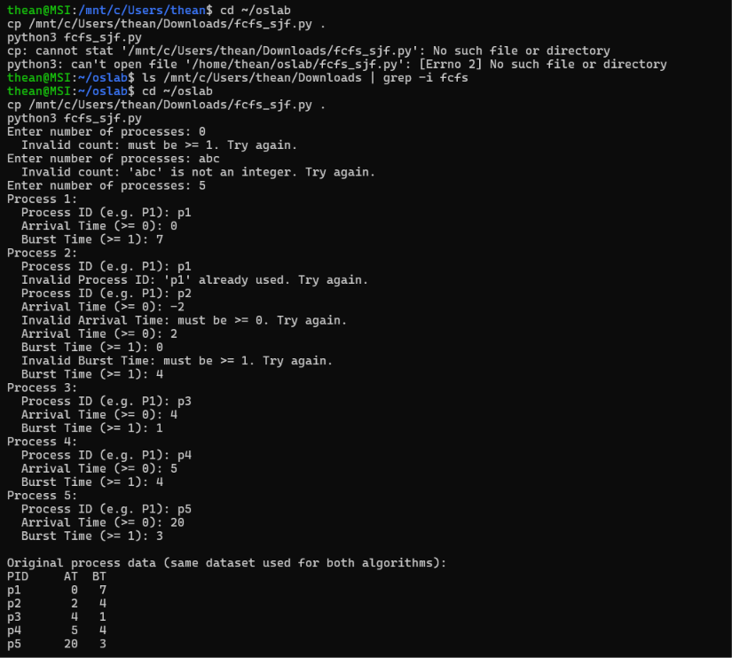
Screenshot 1: Input and validation - invalid count (0, abc), duplicate PID, negative arrival time and zero burst time are rejected; valid dataset accepted and original data displayed (Tasks 1, 2, 3, 9)
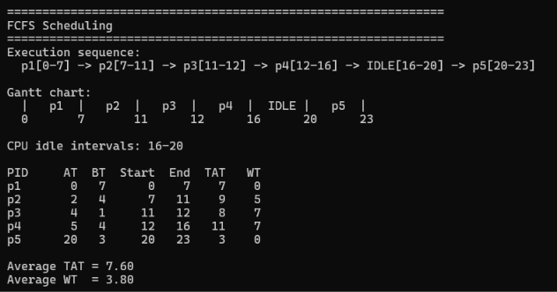
Screenshot 2: FCFS - execution sequence, Gantt chart, CPU idle interval 16-20, and table with Average WT = 3.80 (Tasks 4, 7, 8)
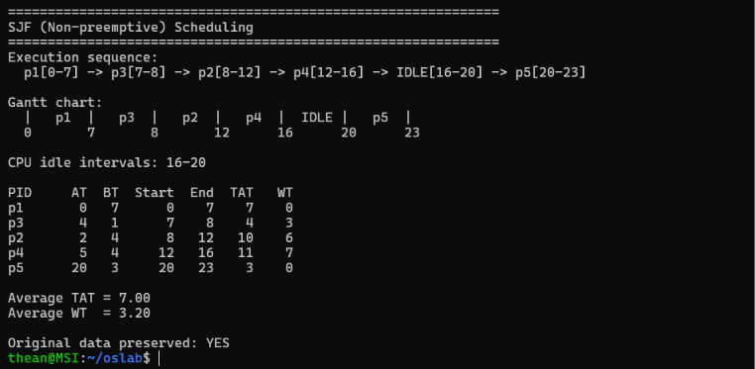
Screenshot 3: Non-preemptive SJF - execution sequence, Gantt chart, CPU idle interval 16-20, Average WT =
3.20, original data preserved (Tasks 3, 5, 7, 8)
Source Code: fcfs_sjf.py
"""FCFS and Non-preemptive SJF CPU Scheduling.
Tie-breaking rule (both algorithms):
- Earlier arrival time first
- If still tied, smaller Process ID (input order) first
""" import copy
# ---------- Task 1 & 2: Input with validation ---------def read_int(prompt, minimum, label): while True:
raw = input(prompt).strip() try:
value = int(raw) except ValueError:
print(f" Invalid {label}: '{raw}' is not an integer. Try again.") continue if value < minimum:
print(f" Invalid {label}: must be >= {minimum}. Try again.") continue return value
def read_processes():
n = read_int("Enter number of processes: ", 1, "count") processes, seen = [], set() for i in range(1, n + 1): print(f"Process {i}:") while True:
pid = input(" Process ID (e.g. P1): ").strip() if not pid:
print(" Invalid Process ID: cannot be empty. Try again.") elif pid in seen:
print(f" Invalid Process ID: '{pid}' already used. Try again.") else: seen.add(pid) break at = read_int(" Arrival Time (>= 0): ", 0, "Arrival Time") bt = read_int(" Burst Time (>= 1): ", 1, "Burst Time") processes.append({"pid": pid, "at": at, "bt": bt, "order": i}) return processes
# ---------- Scheduling core ---------def fcfs(procs):
procs = sorted(procs, key=lambda p: (p["at"], p["order"])) # Task 4 time, timeline, result = 0, [], [] for p in procs:
if time < p["at"]: timeline.append(("IDLE", time, p["at"])) # Task 7 time = p["at"] start, end = time, time + p["bt"] timeline.append((p["pid"], start, end)) result.append(make_row(p, start, end)) time = end return timeline, result
def sjf(procs):
remaining = list(procs) time, timeline, result = 0, [], [] while remaining:
ready = [p for p in remaining if p["at"] <= time] if not ready: # Task 7 next_at = min(p["at"] for p in remaining) timeline.append(("IDLE", time, next_at)) time = next_at continue # Task 5 & 6: shortest burst, tie -> earlier arrival -> smaller order p = min(ready, key=lambda x: (x["bt"], x["at"], x["order"])) start, end = time, time + p["bt"] timeline.append((p["pid"], start, end)) result.append(make_row(p, start, end)) remaining.remove(p) time = end return timeline, result def make_row(p, start, end): tat = end - p["at"]
return {"pid": p["pid"], "at": p["at"], "bt": p["bt"], "start": start, "end": end, "tat": tat, "wt": tat - p["bt"]}
# ---------- Task 8: Display ---------def show(title, timeline, result):
print("\n" + "=" * 62) print(f"{title}") print("=" * 62) print("Execution sequence:") print(" " + " -> ".join(f"{n}[{s}-{e}]" for n, s, e in timeline)) print("\nGantt chart:") bar = "|" + "|".join(f" {n} ".center(7) for n, _, _ in timeline) + "|" marks = f"{timeline[0][1]:<8}" + "".join(f"{e:<8}" for _, _, e in timeline) print(" " + bar) print(" " + marks) idle = [(s, e) for n, s, e in timeline if n == "IDLE"] if idle:
print("\nCPU idle intervals: " + ", ".join(f"{s}-{e}" for s, e in idle)) else:
print("\nCPU idle intervals: None") print("\n{:<6}{:>4}{:>4}{:>7}{:>5}{:>5}{:>5}".format( "PID", "AT", "BT", "Start", "End", "TAT", "WT")) for r in sorted(result, key=lambda r: r["start"]): print("{:<6}{:>4}{:>4}{:>7}{:>5}{:>5}{:>5}".format( r["pid"], r["at"], r["bt"], r["start"], r["end"], r["tat"], r["wt"])) n = len(result) print(f"\nAverage TAT = {sum(r['tat'] for r in result) / n:.2f}") print(f"Average WT = {sum(r['wt'] for r in result) / n:.2f}")
def main():
original = read_processes() backup = copy.deepcopy(original) # Task 3: preserve original data
print("\nOriginal process data (same dataset used for both algorithms):") print("{:<6}{:>4}{:>4}".format("PID", "AT", "BT")) for p in original: print("{:<6}{:>4}{:>4}".format(p["pid"], p["at"], p["bt"]))
# Task 9: same dataset passed (as independent copies) to both algorithms t1, r1 = fcfs(copy.deepcopy(original)) t2, r2 = sjf(copy.deepcopy(original))
show("FCFS Scheduling", t1, r1) show("SJF (Non-preemptive) Scheduling", t2, r2)
print("\nOriginal data preserved:", "YES" if original == backup else "NO")
if __name__ == "__main__":
main()

